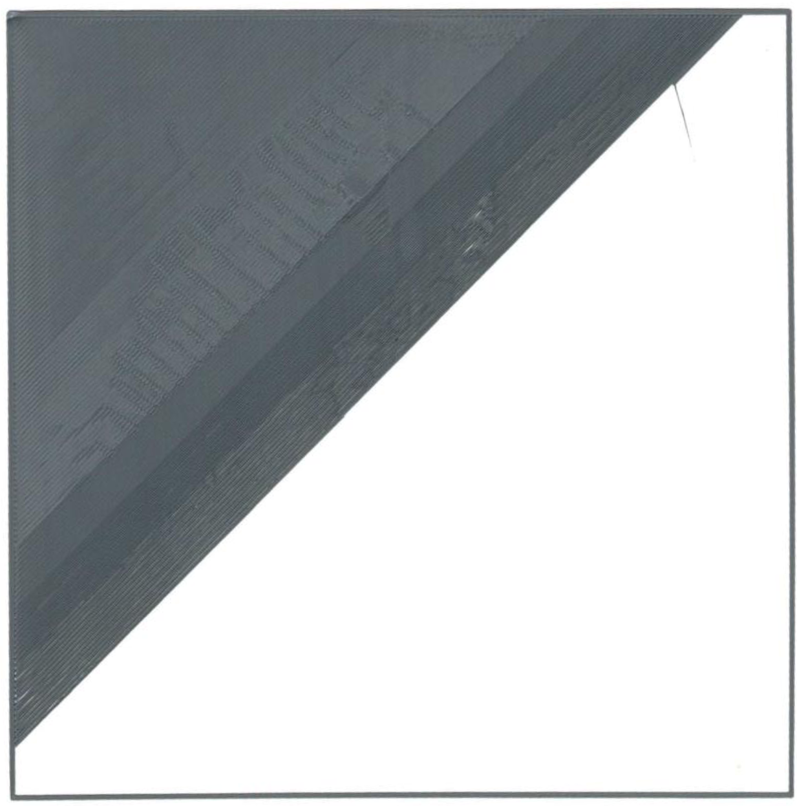Ein Bild, das Text enthält.

*z6 = -2,145 mm*

*z5 = -2,195 mm*

*z4 = -2,245 mm*

*z3 = -2,445 mm*

*z2 = -2,395 mm*

*z1 = -2,345 mm*

*z0 = -2,295 mm*

*z6 = -2,145 mm*

*z5 = -2,195 mm*

*z4 = -2,245 mm*

*z3 = -2,445 mm*

*z2 = -2,395 mm*

*z1 = -2,345 mm*

*z0 = -2,295 mm*